Summary Tables for Naming Carbon Compounds
TABLE 1: Prefixes for naming carbon chains
Prefix | meth | eth | prop | but | pent | hex | hept | oct | non | dec
Number of Carbon  atoms in the chain | 1 | 2 | 3 | 4 | 5 | 6 | 7 | 8 | 9 | 10
TABLE 2: Hydrocarbons: compounds which contain only carbon and hydrogen
Type of Compound | Prefix | Suffix | Functional Group | Example | Name
Alkyl group  (side-chain or branch) | see TABLE 1 | -yl | Alkane less 1 terminal hydrogen | 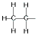 | ethyl
Alkane | see TABLE 1 | -ane | contains single bonds between carbon atoms | 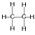 | ethane
Alkene | see TABLE 1 | -ene | contains a double bond between 2 carbon atoms | 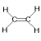 | ethene
Alkyne | see TABLE 1 | -yne | contains a triple bond between 2 carbon atoms | 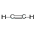 | ethyne
Cyclic Hydrocarbons | cyclo | -ane, -ene or -yne  (as above) | carbon atoms form a ring | 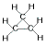 | cyclopropane

IUPAC Rules for Alkane Nomenclature
1. Find and name the longest continuous carbon chain.
2. Identify and name groups attached to this chain.
3. Number the chain consecutively, starting at the end nearest a substituent (side group) group.
4. Designate the location of each substituent group by an appropriate number and name.
5. Assemble the name, listing groups in alphabetical order using the full name (e.g. butyl before propyl, ethyl before methyl etc.).
The prefixes di (two), tri (three), tetra (four) etc., are used to designate several groups of the same kind, e.g. four methyl (CH₃−) groups = terra methyl, two chlorine atoms (Cl−) = dichloro). These prefixes are not considered when alphabetizing.

IUPAC Rules for Alkene and Cycloalkene Nomenclature
1. The -ene suffix (ending) indicates an alkene or cycloalkene.
2. The longest chain chosen for the root name must include both carbon atoms of the double bond.
3. The root chain must be numbered from the end nearest a double bond carbon atom. If the double bond is in the center of the chain, the nearest substituent rule is used to determine the end where numbering starts.
4. The smaller of the two numbers designating the carbon atoms of the double bond is used as the double bond locator. If more than one double bond is present the compound is named as a diene, tr
5. In cycloalkenes the double bond carbons are assigned ring locations #1 and #2. Which of the two is #1 may be determined by the nearest substituent rule.
Question 1.
Set 1: Assign IUPAC names to the following hydrocarbons
1  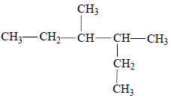 | 2  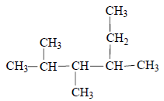
IUPAC  Name | IUPAC  Name
3  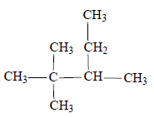 | 4  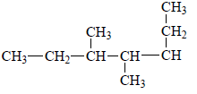
IUPAC  Name | IUPAC  Name
5  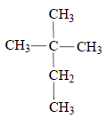 | 6  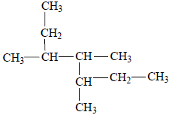
IUPAC  Name | IUPAC  Name
7  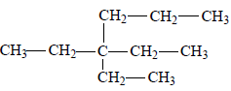 | 8  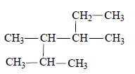
IUPAC  Name | IUPAC  Name
9  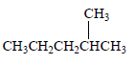 | 10  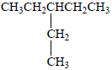
IUPAC  Name | IUPAC  Name
11  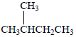 | 12  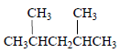
IUPAC  Name | IUPAC  Name
13  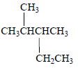 | 14  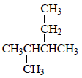
IUPAC  Name | IUPAC  Name

Set 2: Assign IUPAC names to the following hydrocarbons
1  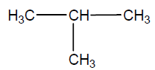 | 2  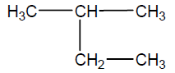
IUPAC  Name | IUPAC  Name
3  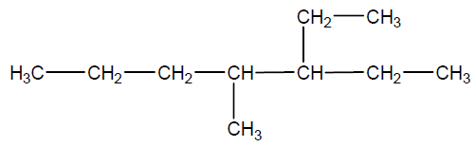 | 4  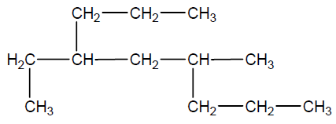
IUPAC  Name | IUPAC  Name
5  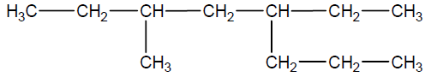 | 6  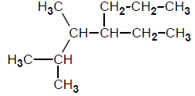
IUPAC  Name | IUPAC  Name
7  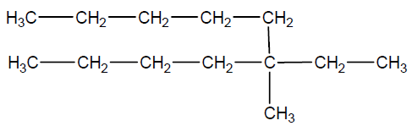 | 8  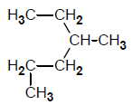
IUPAC  Name | IUPAC  Name
9  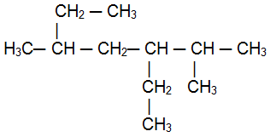 | 10  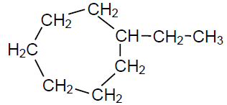
IUPAC  Name | IUPAC  Name
11  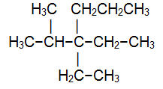 | 12  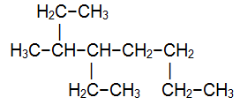
IUPAC  Name | IUPAC  Name
13  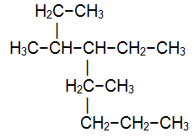 | 14  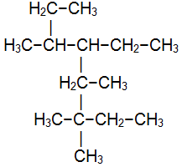
IUPAC  Name | IUPAC  Name

Set 3: Draw structures for the following compounds
1 | 2
3-ethyl-4-methylhexane | 2,3,4-trimethylhexane
3 | 4
3,3-diethylheptane | 3-ethyl-3-methylpentane
5 | 6
3-ethyl-3,5,5-trimethyloctane | 2,4-dimethylpentane
7 | 8
2,2,3,4,4-pentamethylpentane | 3,5-diethylheptane
9 | 10
3-ethyl-2,2,4-trimethylpentane | 3,3-diethyl-2,2-dimethylhexane
11 | 12
3-ethyl-2-methyl-4-propyloctane | 3-ethyl-2,4,5-trimethyl-5-propyloctane
Question 2.
Set 1: Assign IUPAC names to the following hydrocarbons
1 | 2  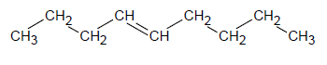
IUPAC  Name | IUPAC  Name
3  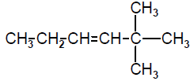 | 4  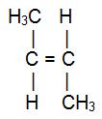
IUPAC  Name | IUPAC  Name
5  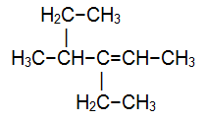 | 6  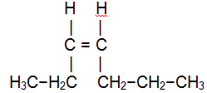
IUPAC  Name | IUPAC  Name
7  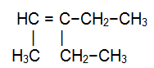 | 8  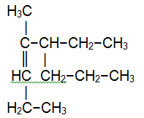
IUPAC  Name | IUPAC  Name
9  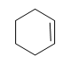 | 10  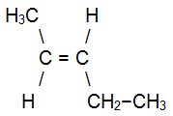
IUPAC  Name | IUPAC  Name
11  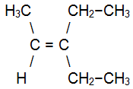 | 12  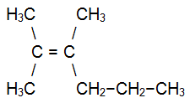
IUPAC  Name | IUPAC  Name
13  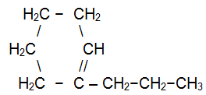 | 14
IUPAC  Name | IUPAC  Name
15  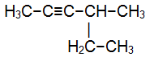 | 16  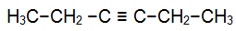
IUPAC  Name | IUPAC  Name

Set 2: Assign IUPAC names to the following compounds
1  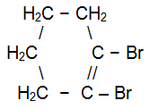 | 2  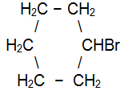
IUPAC  Name | IUPAC  Name
3  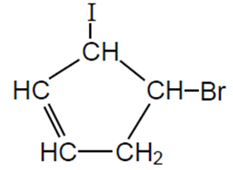 | 4  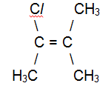
IUPAC  Name | IUPAC  Name
5  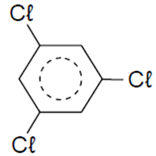 | 6  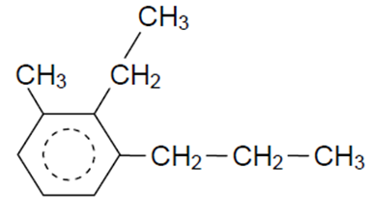
IUPAC  Name | IUPAC  Name
7  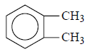 | 8  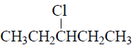
IUPAC  Name | IUPAC  Name
9  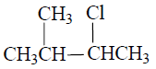 | 10  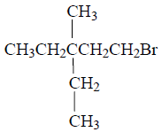
IUPAC  Name | IUPAC  Name
11  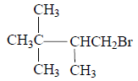 | 12  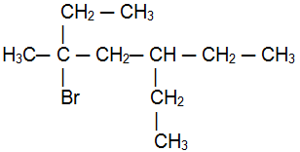
IUPAC  Name | IUPAC  Name
13  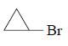 | 14  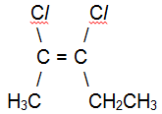
IUPAC  Name | IUPAC  Name
15  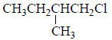 | 16  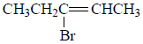
IUPAC  Name | IUPAC  Name

Set 3: Draw structures for the following compounds
1 | 2
2-bromopropane | 2-methyl-1-pentene
3 | 4
2-chloro-5-ethyloctane | 3-bromocyclohexene
5 | 6
cis-2-butene | 1,3-diethycyclohexane
7 | 8
5,6-dimethyl-1-octyne | 4-methyl-2-heptene
9 | 10
5-bromo-5-chloro-4-ethyl-3-hexene | 2,2,5,5-tetrachloro-3-hexyne
11 | 12
3-iodo-trans-2-pentene | 1,5-dibromo-2-chloro-3-ethyl-3-methylhexane

Question 3.
Explain why the following molecules have an incorrect name. What is the correct name?

(a) 1,3-dimethylbutane (b) 4-methylpentane
(c) 2,2-diethylbutane (d) 2-ethyl-3-methylpentane

Question 4.
Draw structures corresponding to the following names. Which name is incorrect and what is its correct name.

(a) 2-methyl-3-ethylhexane (b) trans-1-chloro-1-pentene
(c) 3,3-dipropyl-1-butyne (d) 1-iodo-3-methylcycloheptene (e) 2,3-dibromo-4-(methylethyl)nonane (f) 3-(2-bromoethyl)-1-hexene

Question 5.
Indicate which of the following compounds show geometric isomerism, draw the structures and specify them as cis or trans

(a) 1-butene (b) 2-butene
(c) 1,1-dichloroethene (d) 1,2-dichloroethene
(e) 2-methyl-2-butene (f) 1-pentene
(g) 1-chloropropene (h) 1-chloro-2-methyl-2-butene

Question 6.
How many isomers exist for each of the following? Assign each isomer an IUPAC name.

(a) butene (b) pentane
(c) dichloroethene (d) trifluoropropane
(e) clorobutane (f) pentene
(g) hexane (h) bromopentene

Question 7.
Vapour of a certain saturated hydrocarbon was burnt in excess oxygen to produce 6 times its own volume of carbon dioxide, all measurements being made at the same temperature and pressure.

(a) Determine the molecular formula for this hydrocarbon.
(b) Write a balanced chemical equation for its complete combustion in oxygen.
(c) Write the structural formulae and systematic (IUPAC) names for the isomers of this compound.
Question 8.
In excess oxygen and under constant conditions, a hydrocarbon was combusted to produce equal volumes of carbon dioxide and water vapour. Its relative molecular mass as found to be 42.

(a) Determine its molecular formula.
(b) Write the structural formulae and systematic (IUPAC) names for the isomers of this compound.

Answers
Question 1.
Set 1:
1. 3,4-dimethylhexane 2. 2,3,4-trimethylhexane
3. 2,2,3-trimethylpentane 4. 3,4-dimethylheptane
5. 2,2-dimethylbutane 6. 3,4,5-trimethylheptane
7. 3,3-diethylhexane 8. 2,3,4-trimethylhexane
9. 2-methylpentane 10. 3-ethylpentane
11. 2-methylbutane 12. 2,4-dimethylpentane
13. 2,3-dimethylpentane 14. 2,3-dimethylpentane
Set 2:
1. 2-methylpropane 2. 2-methylbutane
3. 3-ethyl-4-methylheptane 4. 4-ethyl-6-methylnonane
5. 5-ethyl-3-methyloctane 6. 4-ethyl-2,3-dimethylheptane
7. 5-ethyl-5-methyldecane 8. 3-methylhexane
9. 3-ethyl-2,5-dimethylheptane 10. ethyl cycloheptane
11. 3,3-diethyl-2-methylhexane 12. 4-ethyl-3-methyloctane
13. 4-ethyl-3,5-dimethyloctane 14. 5-ethyl-3,3,4,6-tetramethyloctane
Set 3:
1  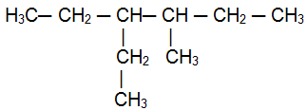 | 2  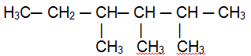 | 3  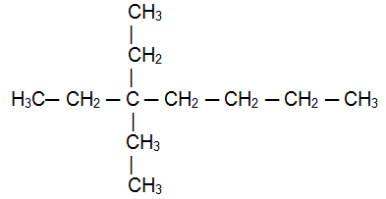
3-ethyl-4-methylhexane | 2,3,4-trimethylhexane | 3,3-diethylheptane
4  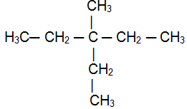 | 5  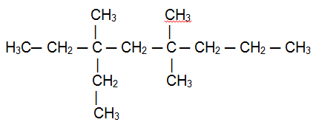 | 6
3-ethyl-3-methylpentane | 3-ethyl-3,5,5-trimethyloctane | 2,4-dimethylpentane
7  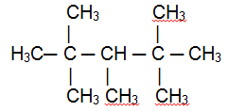 | 8  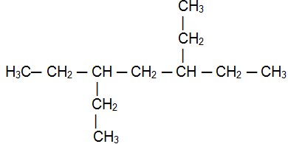 | 9  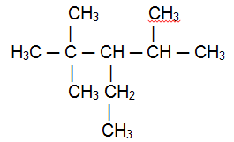
2,2,3,4,4-pentamethylpentane | 3,5-diethylheptane | 3-ethyl-2,2,4-trimethylpentane
10  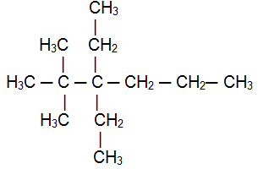 | 11  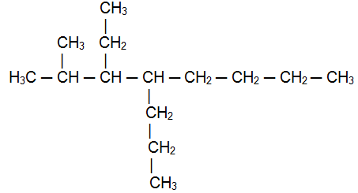 | 12  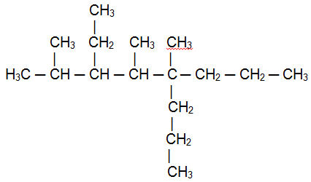
3,3-diethyl-2,2-dimethylhexane | 3-ethyl-2-methyl-4-propyloctane | 3-ethyl-2,4,5-trimethyl-5-propyloctane

Question 2.
Set 1:
1. 2-hexene 2. 4-nonene
3. 2,2-dimethyl-3-hexene 4. trans-2-butene
5. 3-ethyl-4-methyl-2-hexene 6. cis-3-heptene
7. 3-ethyl-2-pentene 8. 5-ethyl-4-methyl-3-octene
9. cyclohexene 10. trans-2-pentene
11. 3-ethyl-2-pentene 12. 2,3-dimethyl-2-hexene
13. 1-propyl cyclohexene 14. propyne
15. 4-methyl-2-hexyne 16. 3-hexyne
Set 2:
1. 1,2-dibromocyclohexene 2. bromocyclohexane
3. 4-bromo-3-iodocyclopentene 4. 2-chloro-3-methyl-2-butene
5. 1,3,5-trichlorobenzene 6. 2-ethyl-1-methyl-3-propylbenzene
7. 1,2-dimethylbenzene 8. 3-chloropentane
9. 2-chloro-3-methylbutane 10. 1-bromo-3-ethyl-3-methylpentane
11. 1-bromo-2,3,3-trimethylbutane 12. 3-bromo-5-ethyl-3-methylheptane
13. bromocyclopropane 14. cis-2,3-dichloro-2-pentene
15. 1-chloro-2-methylbutane 16. 3-bromo-2-pentene
Set 3:
1  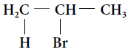 | 2  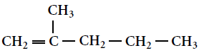 | 3  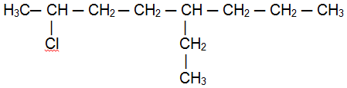
2-bromopropane | 2-methyl-1-pentene | 2-chloro-5-ethyloctane
4  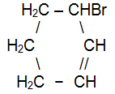 | 5  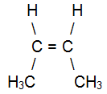 | 6  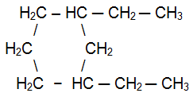
3-bromocyclohexene | cis-2-butene | 1,3-diethycyclohexane
7  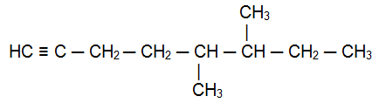 | 8  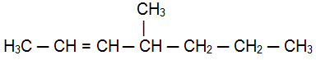 | 9  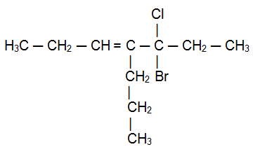
5,6-dimethyl-1-octyne | 4-methyl-2-heptene | 5-bromo-5-chloro-4-ethyl-3-hexene
10  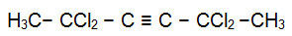 | 11  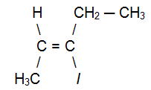 | 12  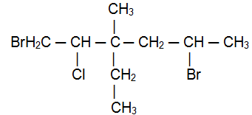
2,2,5,5-tetrachloro-3-hexyne | 3-iodo-trans-2-pentene | 1,5-dibromo-2-chloro-3-ethyl-3-methylhexane

Question 3.

a) hexane b) 2-methylpentane
c) 2-ethyl-2-methylpentane d) 3,4-dimethylhexane

Question 4.

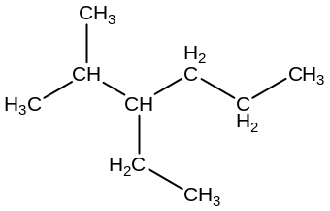 | 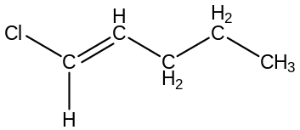 | 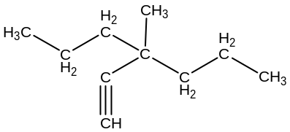
2-methyl-3-ethylhexane | trans-1-chloro-1-pentene | 3,3-dipropyl-1-butyne
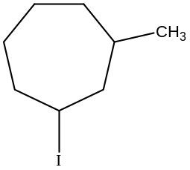 | 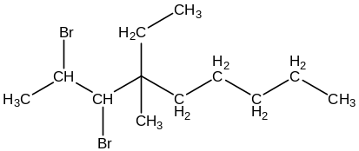 | 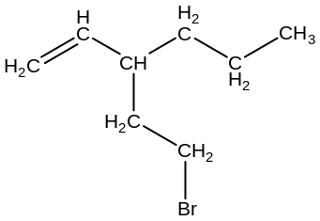
1-iodo-3-methylcycloheptene | 2,3-dibromo-4-(methylethyl)nonane | 3-(2-bromoethyl)-1-hexene

Question 5.

 | 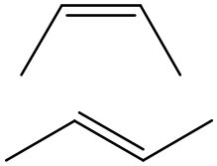 | 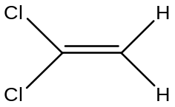 | 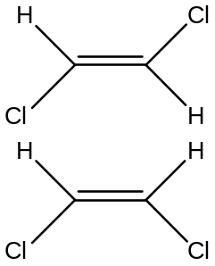
NO | YES | NO | YES
1-butene | 2-butene | 1,1-dichloroethene | 1,2-dichloroethene
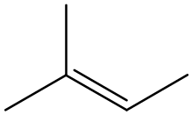 | 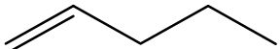 | 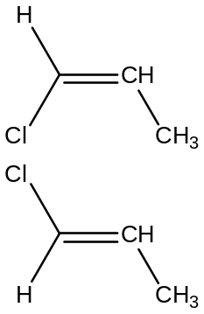 | 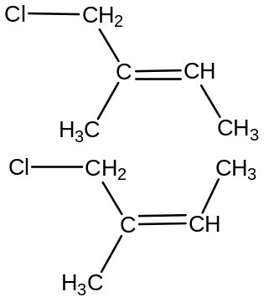
NO | NO | YES | YES
2-methyl-2-butene | 1-pentene | 1-chloropropene | 1-chloro-2-methyl-2-butene

Question 6.
(a)
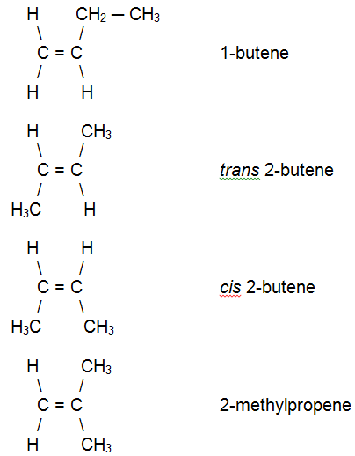
(b)
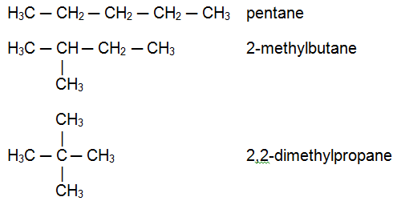

(c)
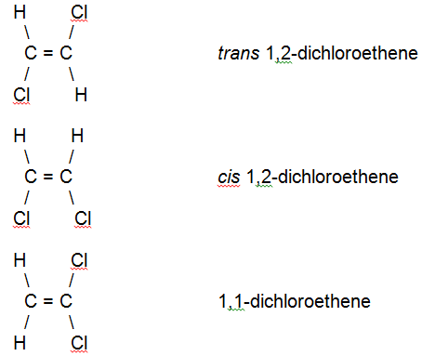
(d)

Question 7.
(a) C₆H₁₄
(b) C₆H₁₄ + 19/2O₂ → 6CO₂ + 7H₂O or 2C₆H₁₄ + 19O₂ → 12CO₂ + 14H₂O
(c)
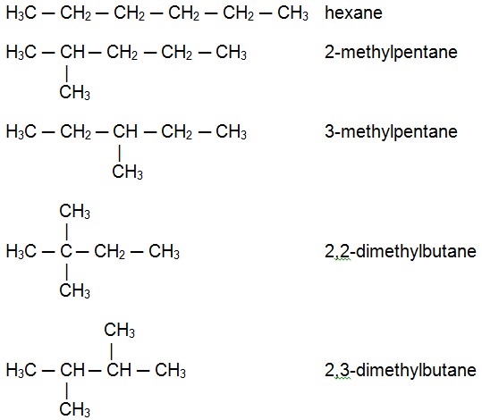
Question 8.
(a) C₃H₆ + 9/2O₂ → 3CO₂ + 3H₂O
(b)
